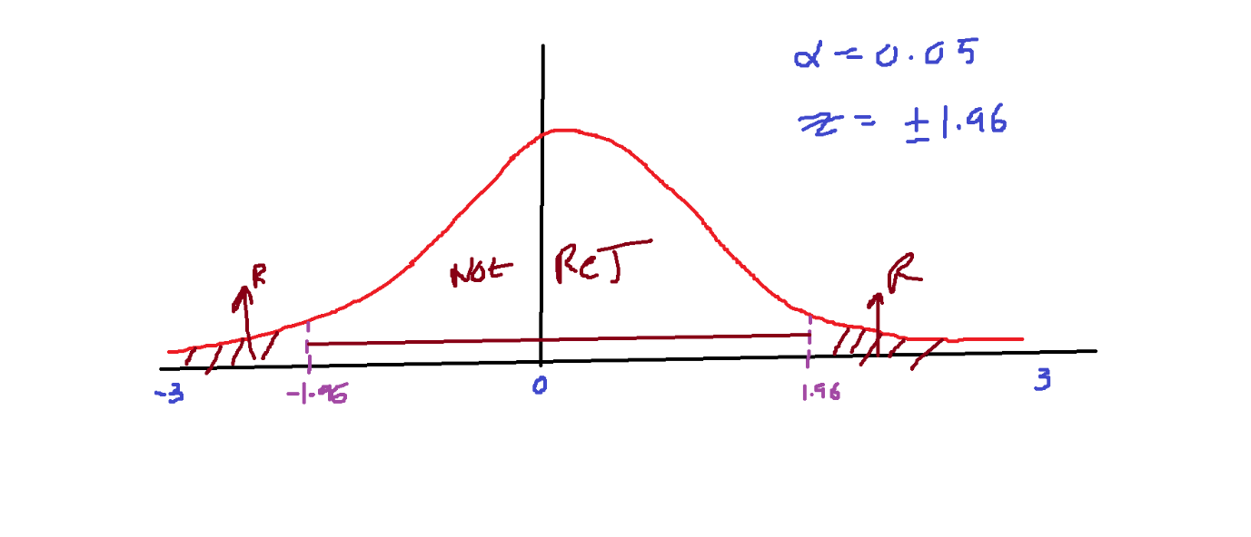

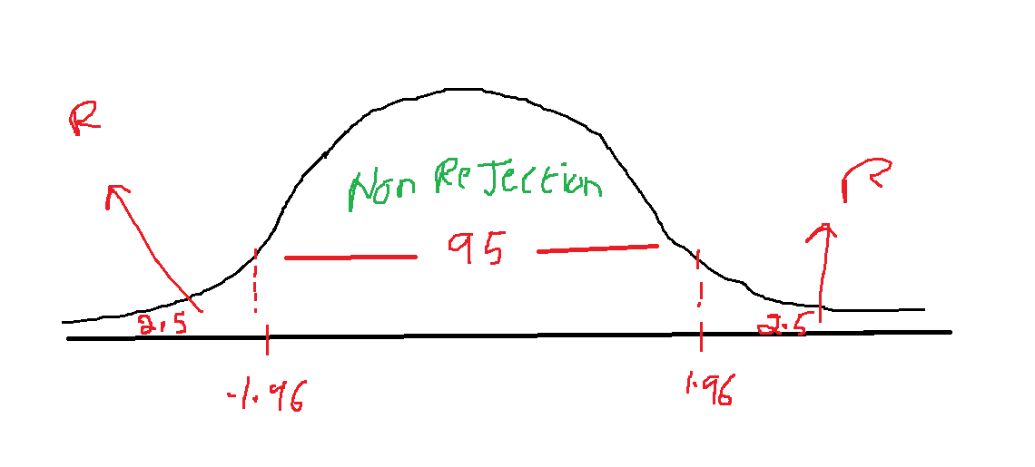



**Question-1:**

In an attempt to determine why customer service is important to managers in the United Kingdom, researchers surveyed managing directors of manufacturing plants in Scotland.* One of the reasons proposed was that customer service is a means of retaining customers. On a scale from 1 to 5, with 1 being low and 5 being high,

The survey respondents rated this reason more highly than any of the others, with a mean response of 4.30. Suppose U.S. researchers believe American manufacturing managers would not rate this reason as highly and conduct a hypothesis test to prove their theory. Alpha is set at .05. Data are gathered and the following results are obtained. Use these data and the eight steps of hypothesis testing to determine whether U.S. managers rate this reason significantly lower than the 4.30 mean ascertained in the United Kingdom. Assume from previous studies that the population standard deviation is 0.574.

3 4 5 5 4 5 : 26

5 4 4 4 4 4 : 25

4 4 4 5 4 4 : 25

4 3 4 4 4 3 : 22

5 4 4 5 4 4 : 26

4 5 : 9

26+25+25+22+26+9/32=4.156

Step-1:

Make the hypothesis

$$H_{0}:Mean response is 4.30$$

$$H_{a}:Mean response is not equal to 4.30$$

**Step-2:**

$$H_{0}: u=4.30$$

$$H_{a}: u≠4.30$$

**Step-3:**

**Significance value :**

$$α=0.05$$

***Step-4:***

***Make critical values***

***1.645 ============ 90%***

***1.96 ============== 95%***

***2.58 ============== 99%***

***Critical values are -1.96 to 1.96***

***Step-5:***

***Make a rejection area and non rejection area***

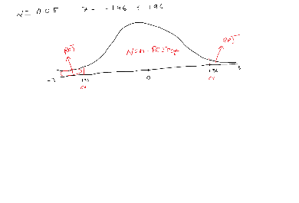

**Step-6:**

**Conduct the test**

3 4 5 5 4 5

5 4 4 4 4 4

4 4 4 5 4 4

4 3 4 4 4 3

5 4 4 5 4 4

4 5

Sample mean = 4.15

$$z=\frac{4.15-4.30}{0.574∕\sqrt{32}}= -1.48$$

$$obsrved value= -1.48$$

**Step-7: Conclusion**

**Not Reject the Null hypothesis**





